**Justice lags legal obligations that are effective in practice**

Rights areas:

* [Justice, victims’ rights and judicial cooperation](https://fra.europa.eu/en/taxonomy/term/982)

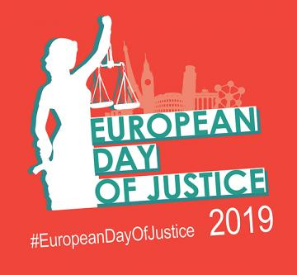

Everyone wants a fair trial when it comes to judicial proceedings. But in practice shortcomings sometimes fail to deliver on the rights of victims and defendants. European Day of Justice is a time to reflect on challenges to ensure Europe offers fair justice for all.

**Publication**

[**Rights in practice: access to a lawyer and procedural rights in criminal and European arrest warrant proceedings**](https://fra.europa.eu/node/37072)

Justice ensures people’s fundamental and human rights are respected and protected.

But for people to believe and have faith in justice, they must also be able to see and trust that justice is done.

This requires a strong and independent judiciary, whose rulings can be relied on to reflect nothing but the law. This also means without interference.

For example, victims of violent crime need to believe that the police, prosecutors and criminal courts investigate, prosecute, convict and punish perpetrators accordingly.

Victims should be able to form part of these proceedings, actively contributing. They need to see that justice is delivering for them.

Too often, this is not the case, as [FRA research shows](https://fra.europa.eu/en/press-release/2019/how-member-states-are-failing-victims-violent-crime-eu-agency-reports).

It shows how often legislation fails to recognise victims as parties to the criminal proceedings. This points to the need for more effective comprehensive support for victims, as well as judicial and police training so they are more in tune with victims’ rights.

Defendants too also often suffer from deficiencies in how their procedural rights are upheld in practice by all those involved throughout the judicial proceedings.

This is true in pure domestic as well as cross-border criminal proceedings.

Recent [FRA findings](https://fra.europa.eu/en/publication/2019/criminal-proceedings-rights) underline how poor information and inadequate access to legal assistance can prevent defendants in criminal proceedings from full access to justice.

Taken together, it shows how justice systems in practice across Member States need to step up in effectively and consistently applying the relevant standards that guarantee victims’ and defendants’ rights.

Only then can we ensure that there is fair and equal access to justice for all.